**Introduction:** This lab teaches about using Simulink for frequency analysis and sampling of continuous time signals.

2. Pre-Lab

2.2

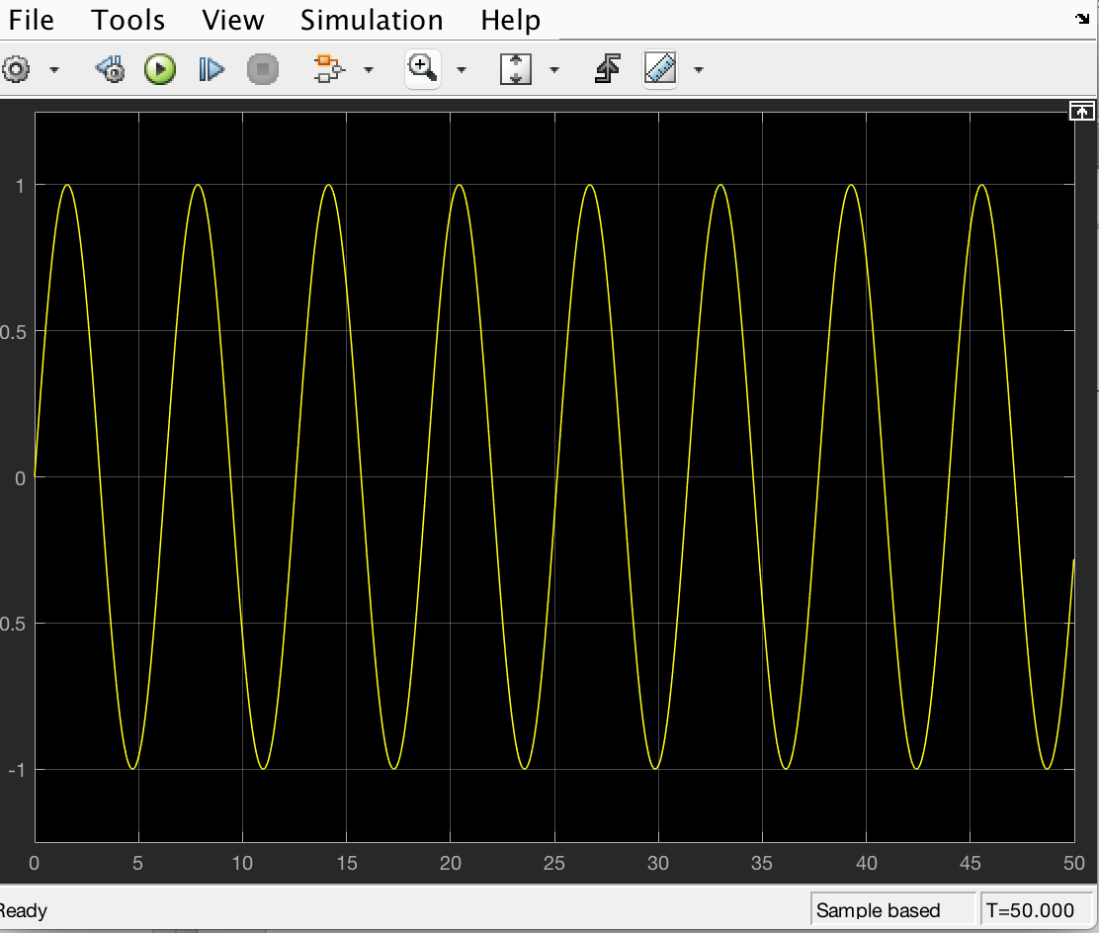

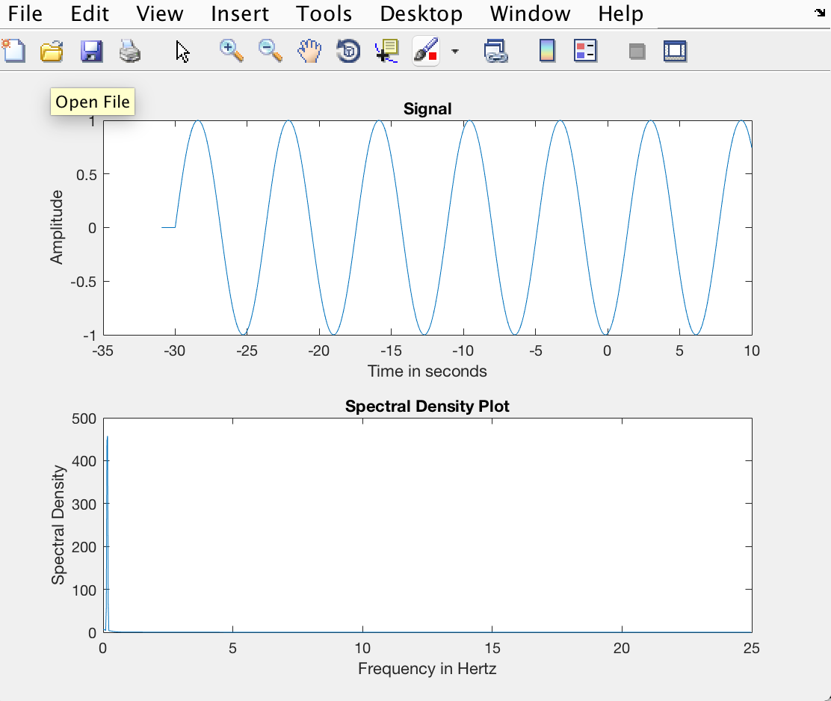

The frequency is at around 0 Hz.

Changing the frequency to 5*pi rad/s: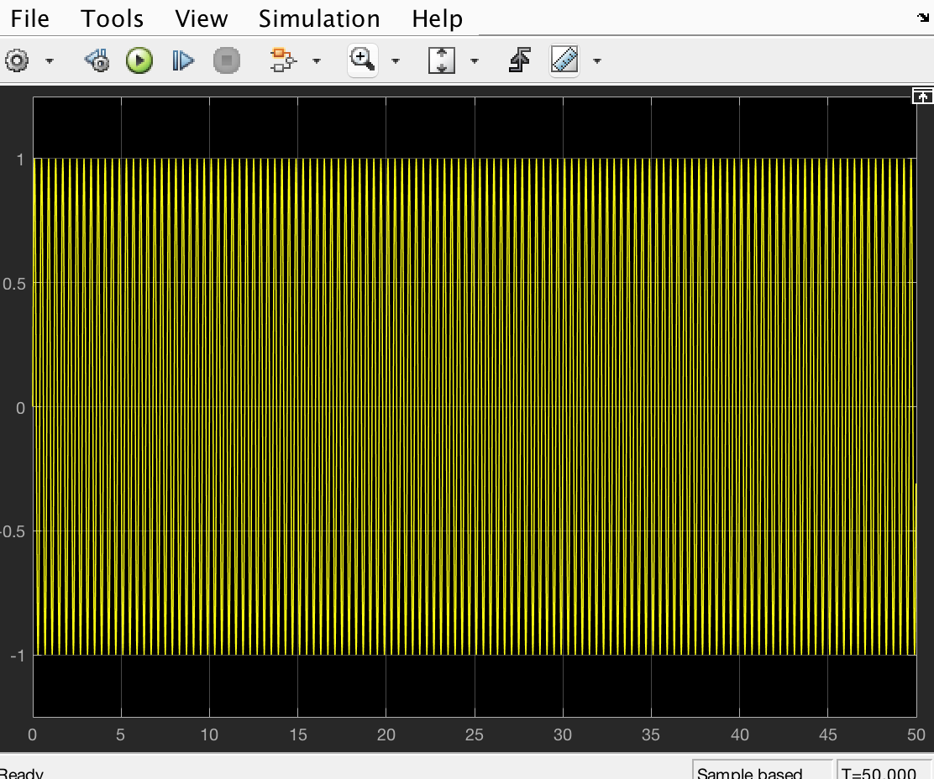

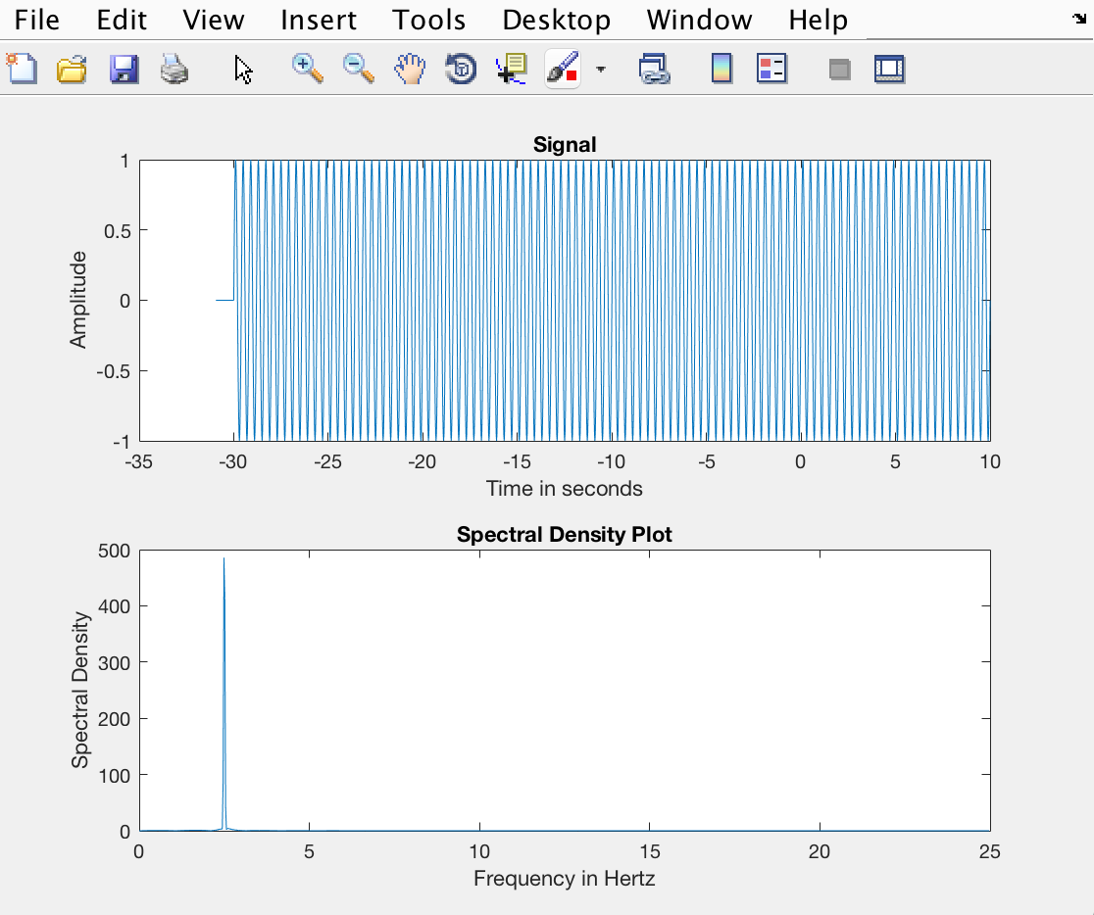

The frequency is peak at around 2.5 Hz.

3.

3.1 When period of square-wave = 2 sec:

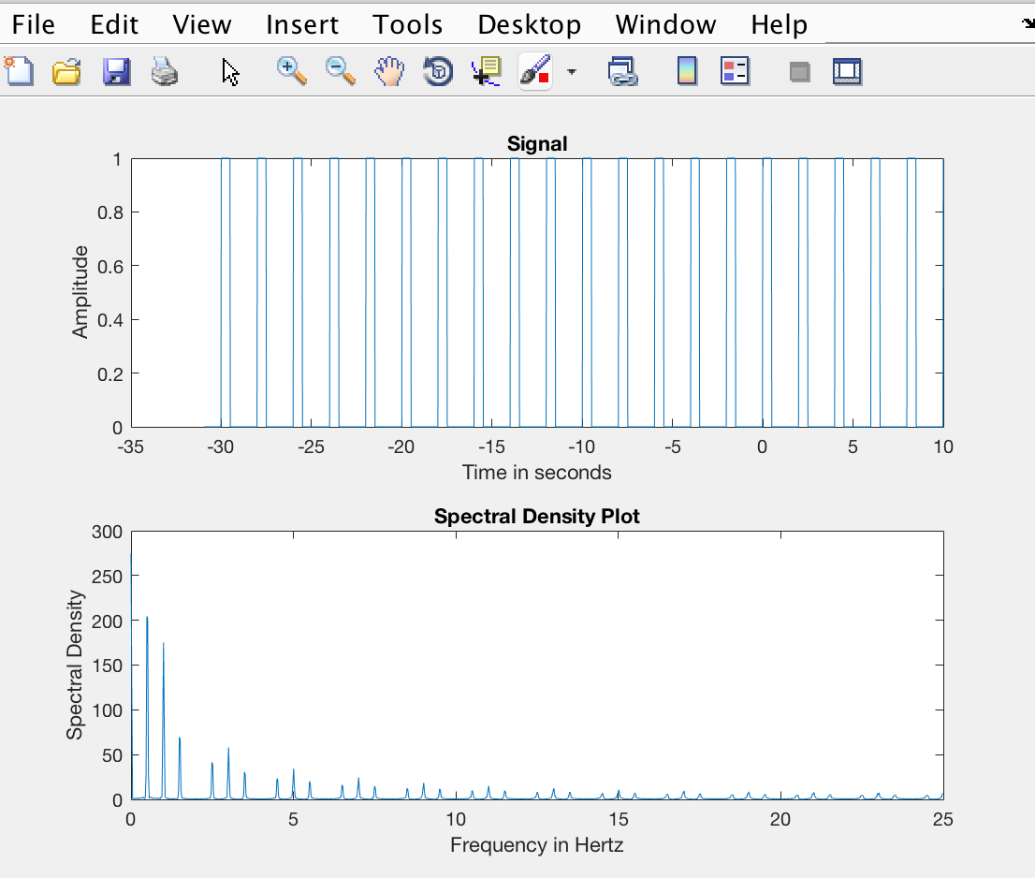

The frequency is spiked around 0.5 Hz, and looks slight different than that seen in the class.

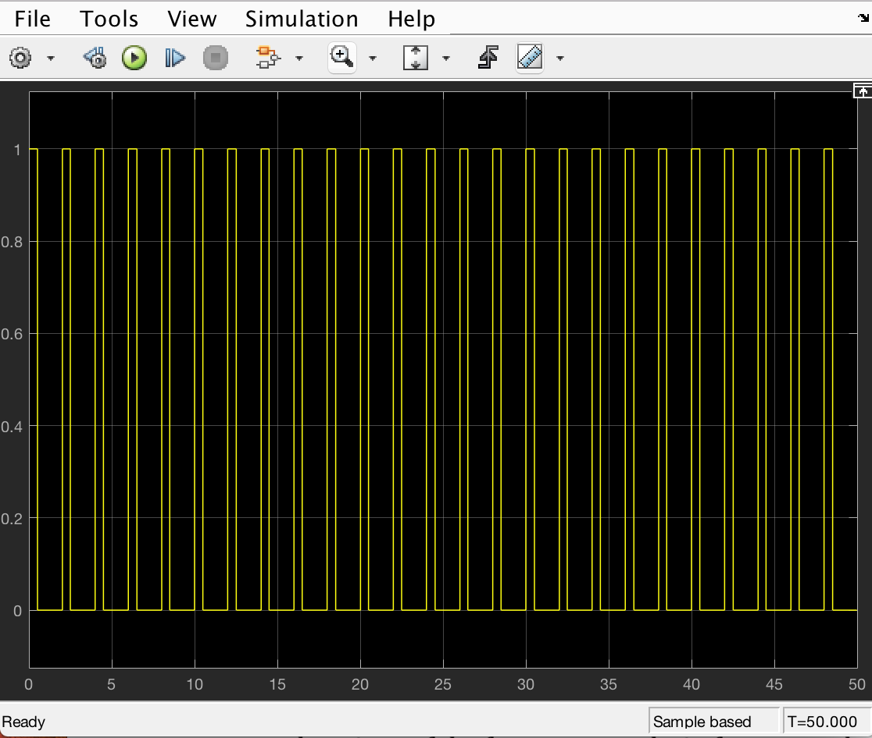

When period = 0.25 sec:

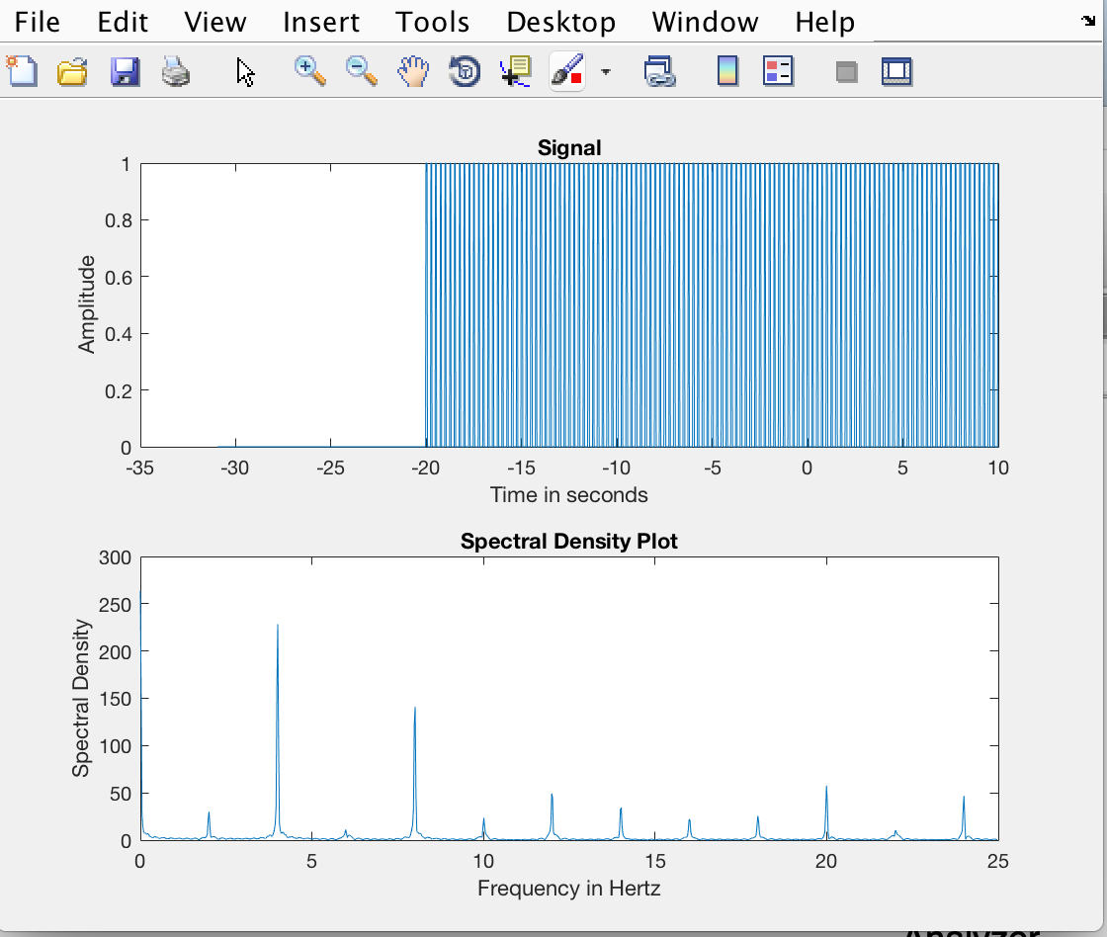

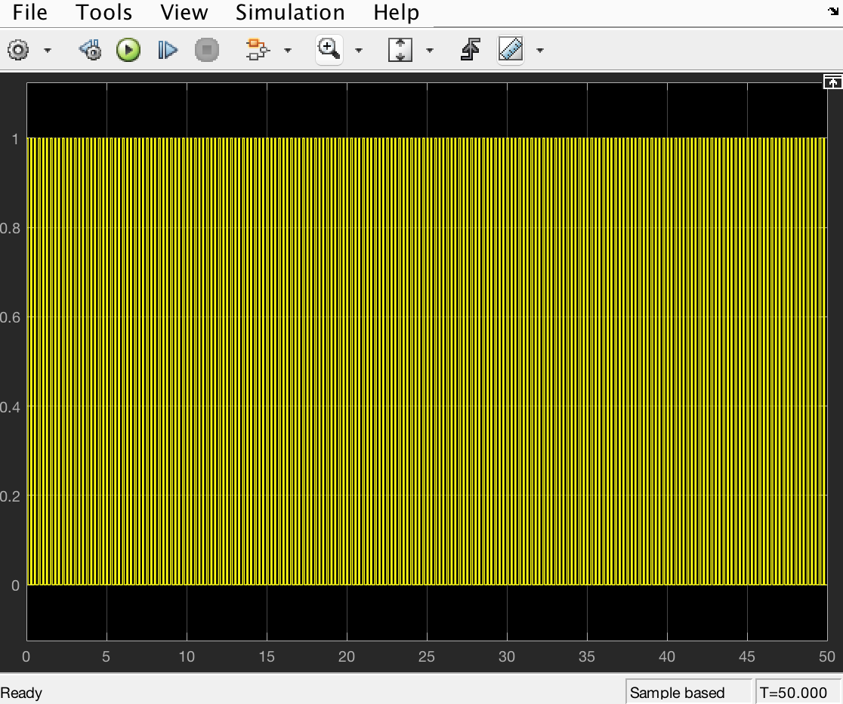

When period = 10 sec:

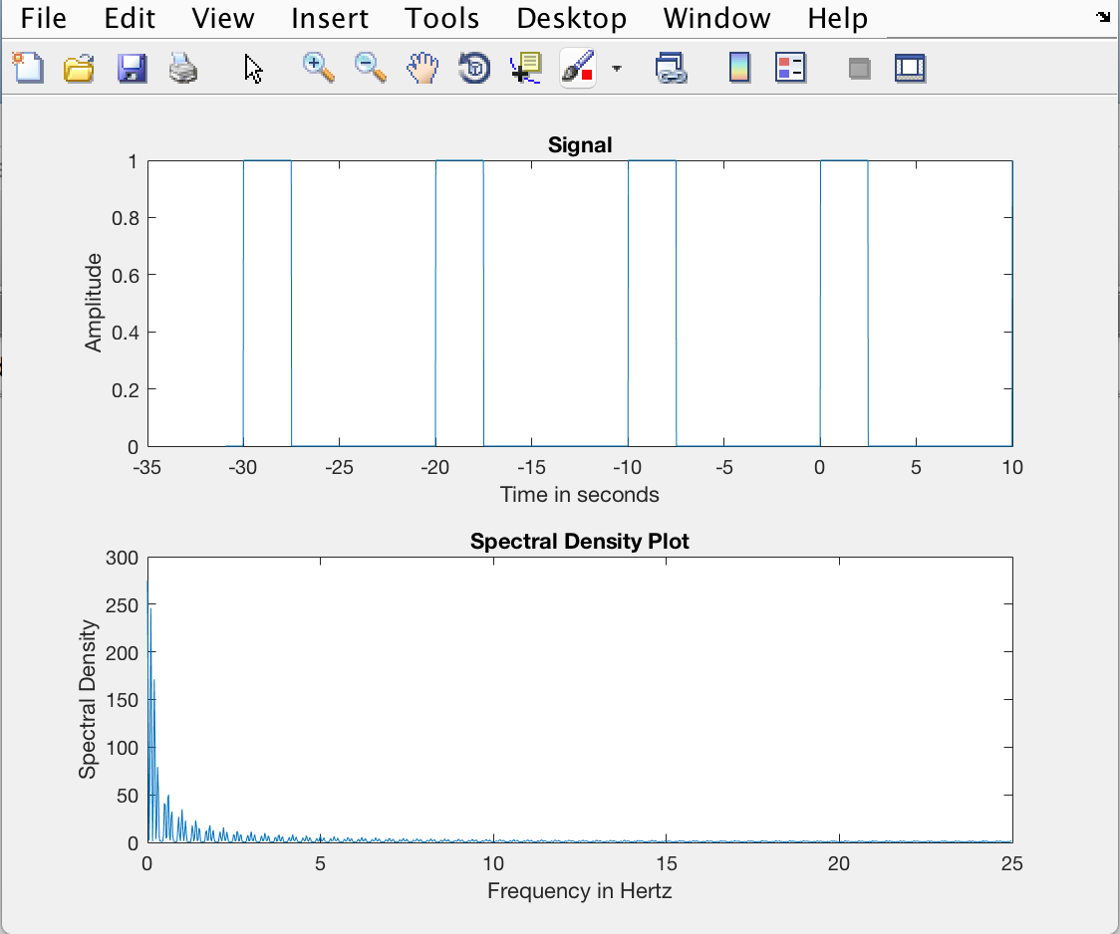

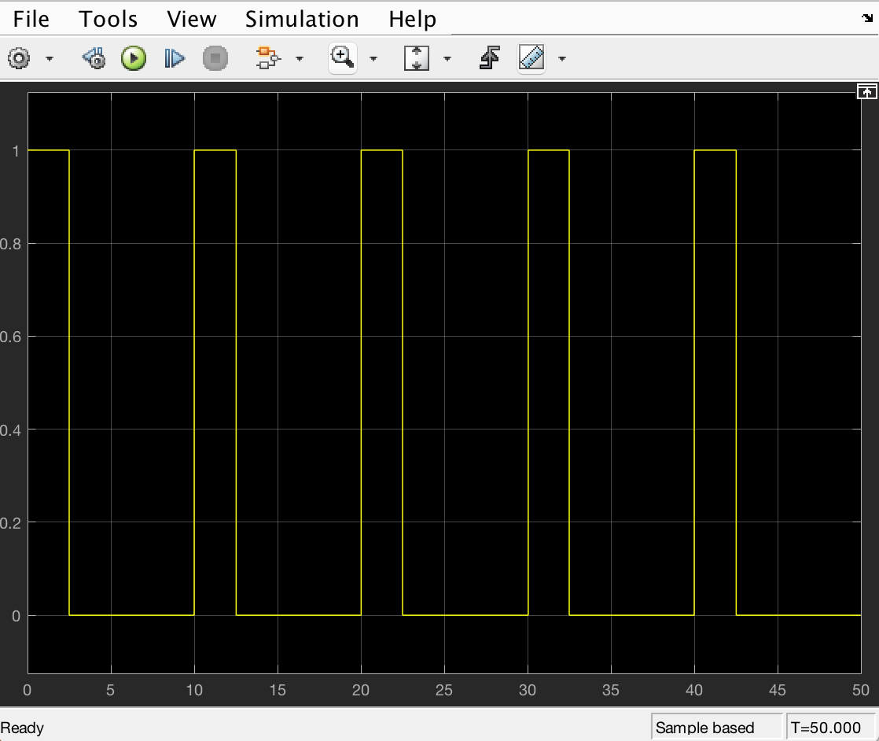

Yes, the results did correspond to the Time-Scaling Property.

Fundamental period and the frequency are inverse of each other.

T0 = 1/f0

3.2

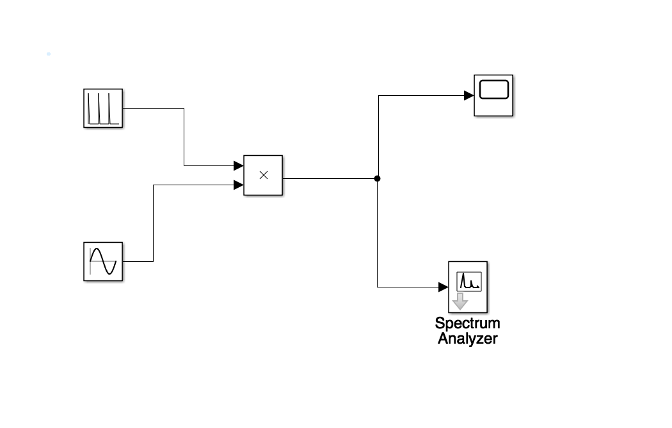

1. Triangular pulse duration =1 sec, Period = 2 sec, Modulating Frequency = 10 Hz:

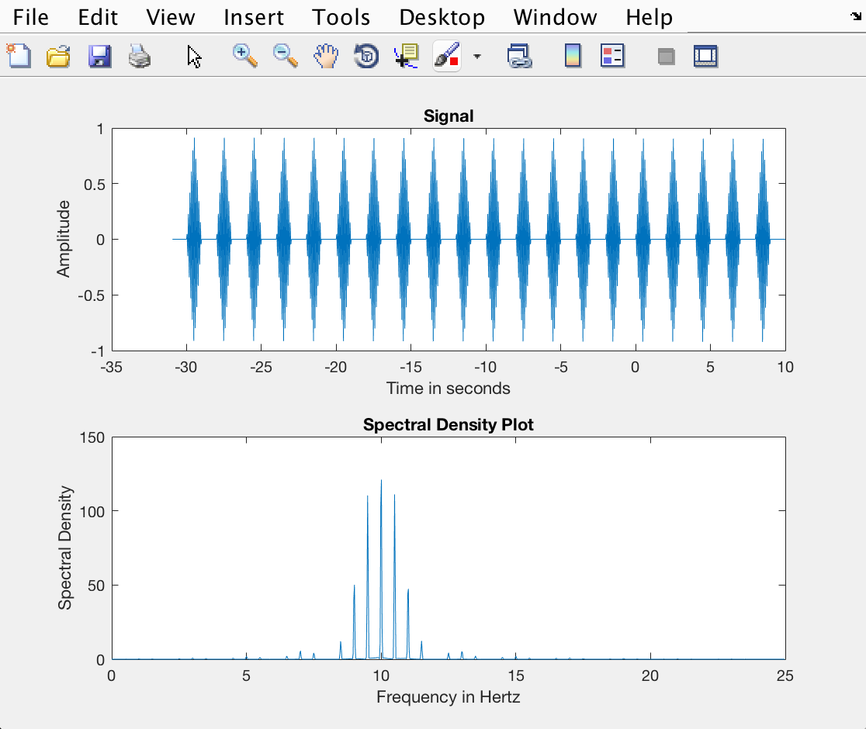

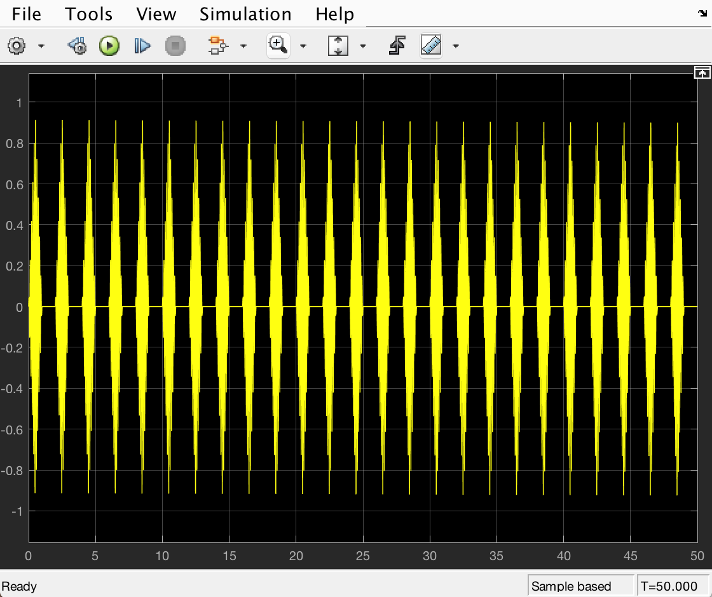

2. Triangular pulse duration =1 sec, Period = 2 sec, Modulating Frequency = 15 Hz

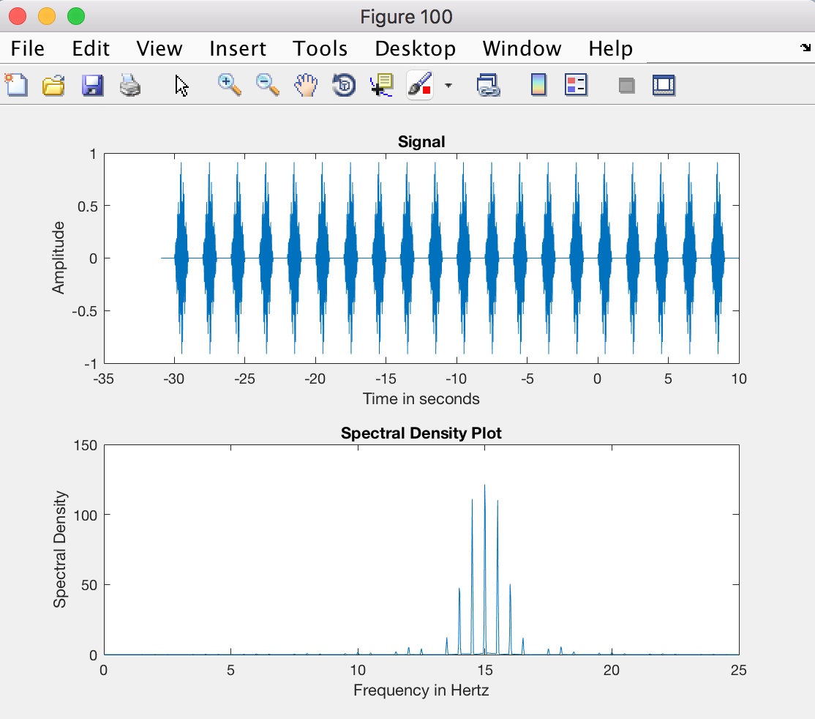

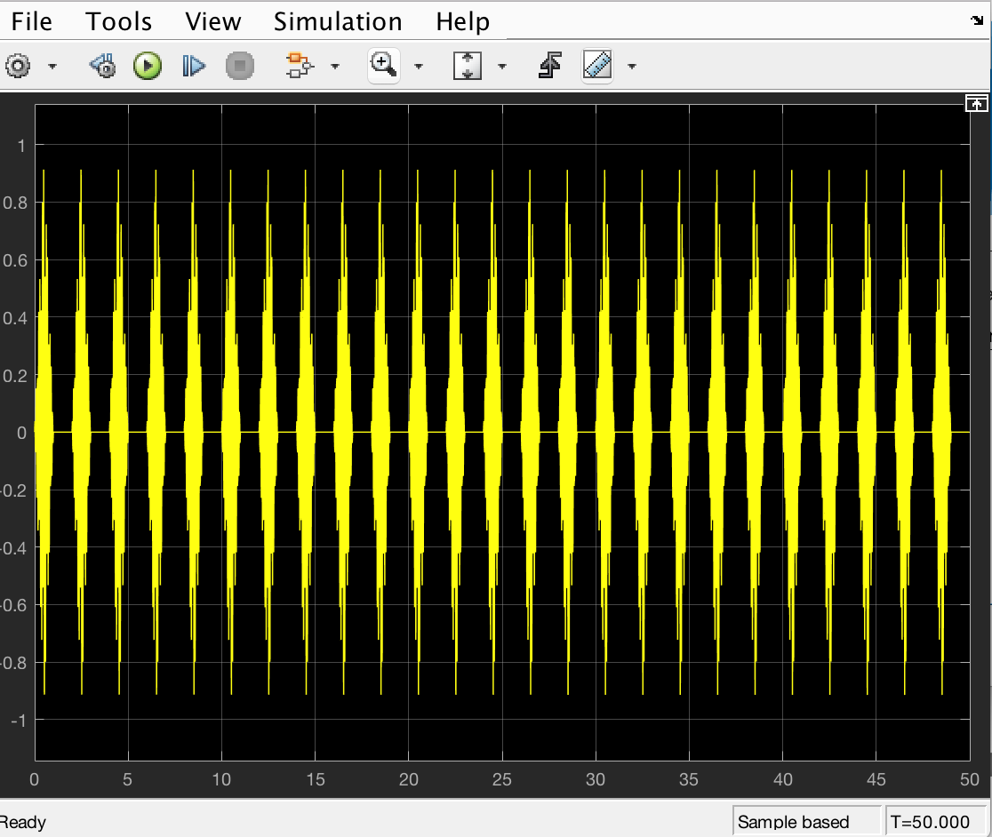

3. Triangular pulse duration =1 sec, Period = 3 sec, Modulating Frequency = 10 Hz

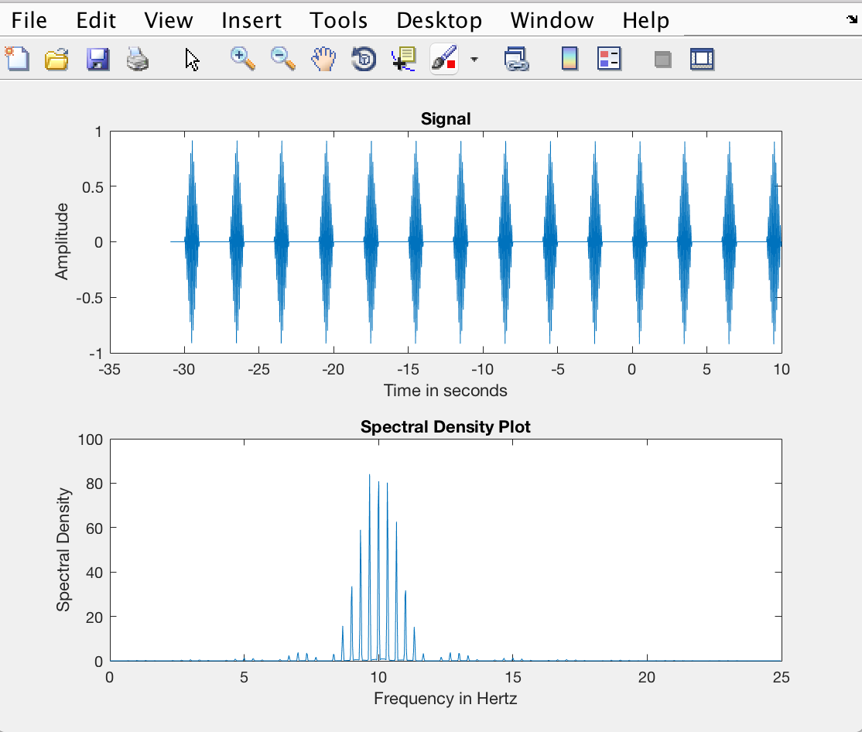

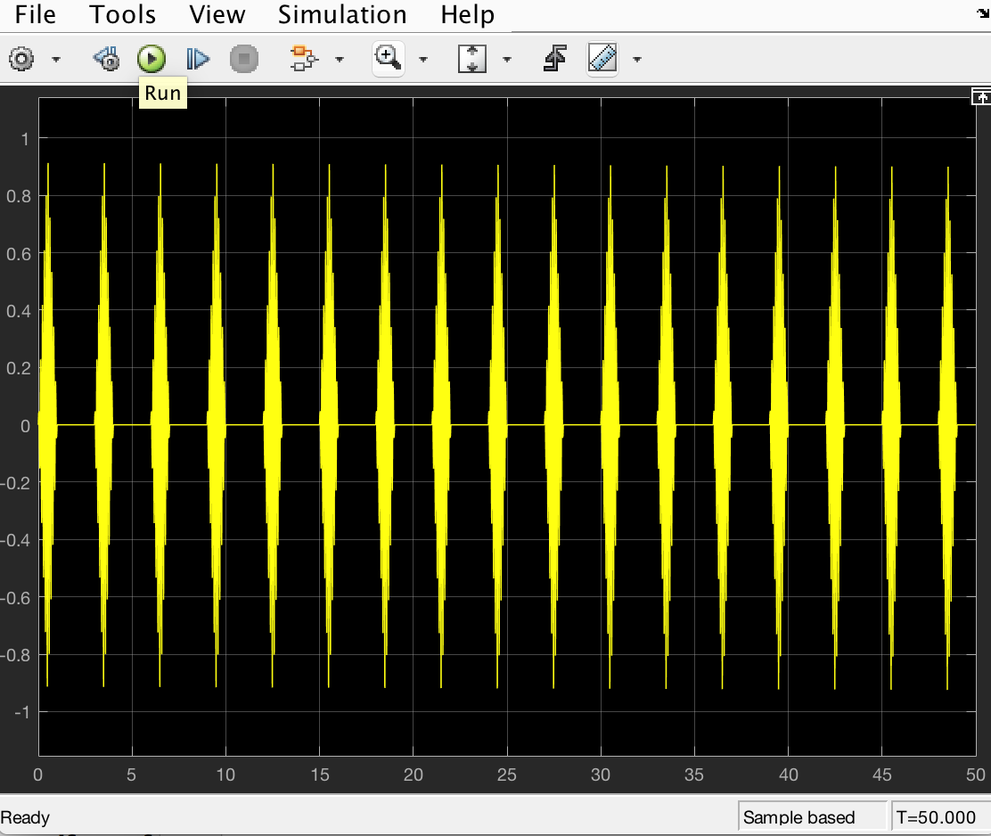

4. Triangular pulse duration =1 sec, Period = 6 sec, Modulating Frequency = 10 Hz

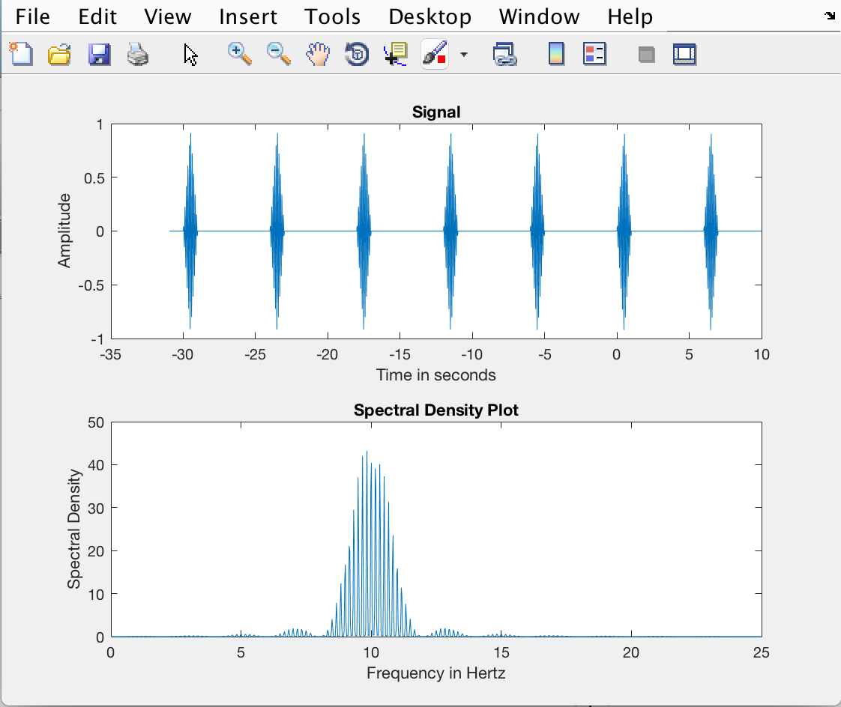

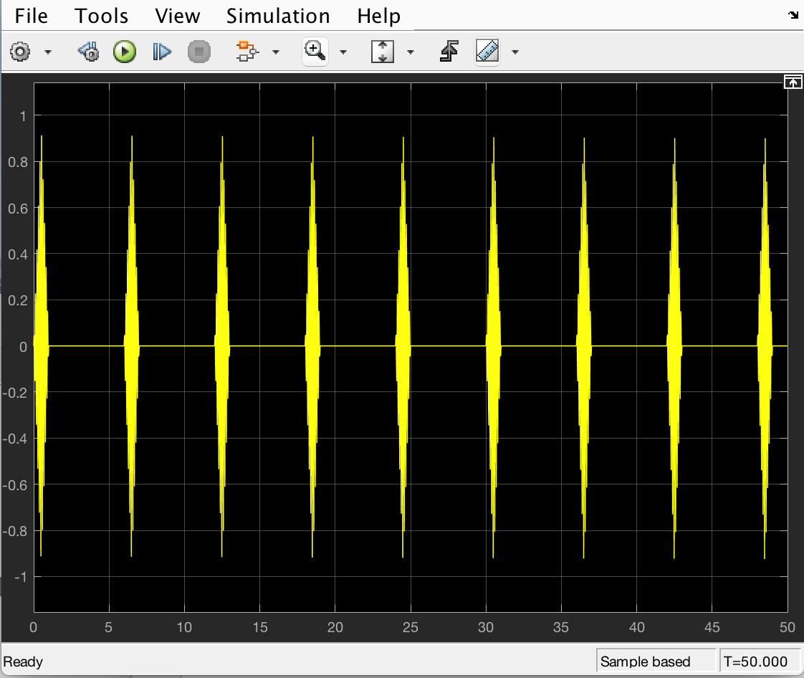

* Changing the modulating frequency increases the density around the center frequency.
* Spectrum have a comb structure due to the modulation property.
* If the period were to increase toward infinity within the limit, then spectral density tends to increase within the limit.

Extra Credit:

